§

**First name and surname**

Title/Education

|  |  |  |
| --- | --- | --- |
| E-post  [E-mail] | Smartphone  [Phone number] | Kuvert  [Address] |

WORK EXPERIENCE

**Employer**

**Job title**

January 2023 – Present

[Description of role and tasks. Here you describe the role and the tasks that you have.]

**Employer**

**Job title**

July 2017 – December 2022

[Description of role and tasks.]

EDUCATION

**Master's degree in […]**

**[university]**

August 2015 – June 2017

[Specialization]

**Bachelor's degree in**

**[university]**

August 2012 – June 2015

[Specialization]

OTHER MERITS & ASSIGNMENTS

* Board member of [...]
* Committee member of […]
* […]

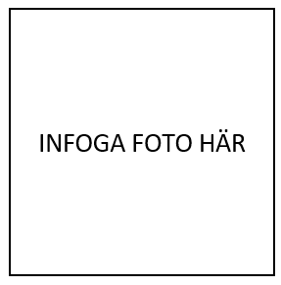

About me

Here you write a text about yourself. The text can be a mini version of a personal letter. The text can also include what goals you have in your career.

Languages

Swedish (mother tongue),

English (fluent).

Skills

Very good knowledge of Word, Excel and PowerPoint.

Other relevant skills.

References

Available upon request.